Practical No. 7:
String Handling in Python
Aim: Write a Python program to demonstrate string handling.
Program 1: Creating and Displaying Strings
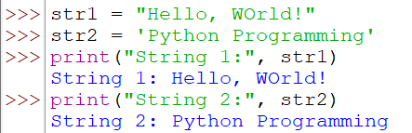

Program 2: Accessing Characters Using Indexing
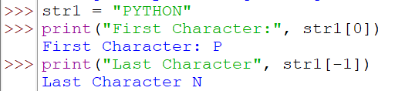

Program 3: String Slicing
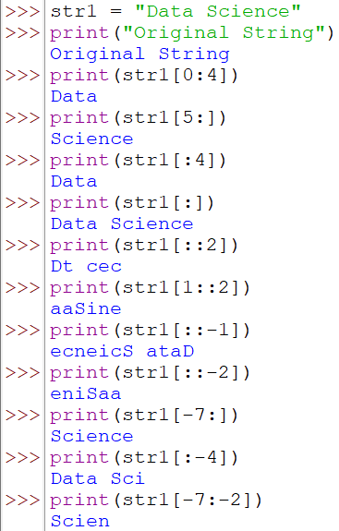

Program 4: String Concatenation
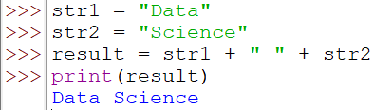

Program 5: String Repetition
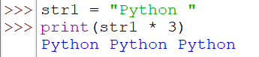

Program 6: String Membership Operators
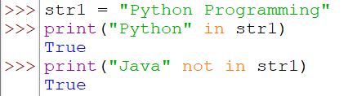

Program 7: String Comparison
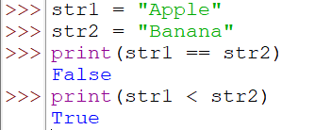

Program 8: Common String Methods
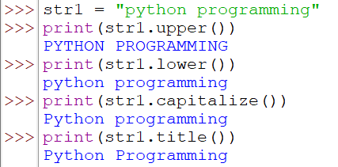

Program 9: Finding and Replacing Substrings
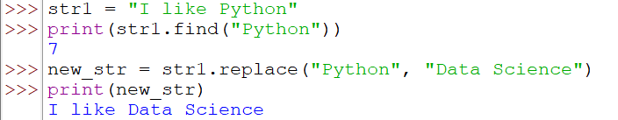

Program 10: Splitting and Joining Strings
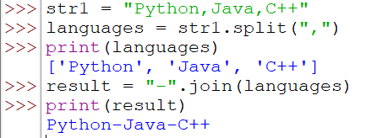

Program 11: Demonstrate strip(), lstrip(), and rstrip() methods
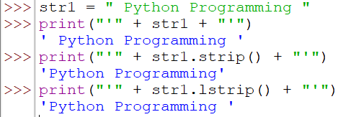
Removing Specified character
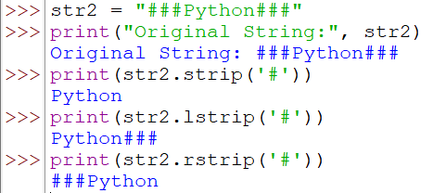

Program 12: Traversing a String
Method 1: Using a for Loop
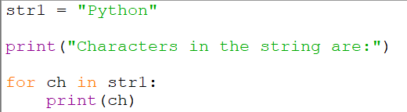
Output
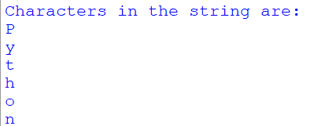

Method 2: Using Indexing
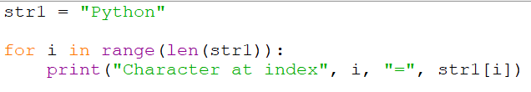
Output
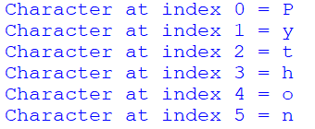

Method 3: Traversing a String in Reverse Order
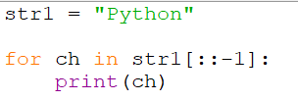

Output
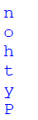

Program 13: Counting Vowels in a String
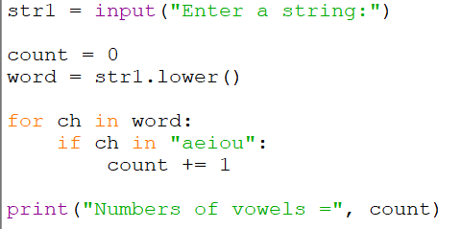

Output
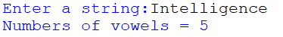

Program 14: Checking Palindrome String
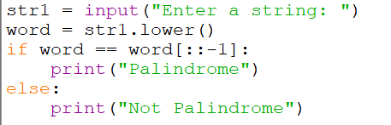

Output 1:
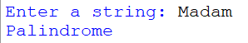

Output 2:


